Linux Commands Execution

pwd- Present working Directory
cd- Change directory
echo $0- It will help to get the details of the current shell
cd .. -Previous directory
cd ../.. – Two steps back

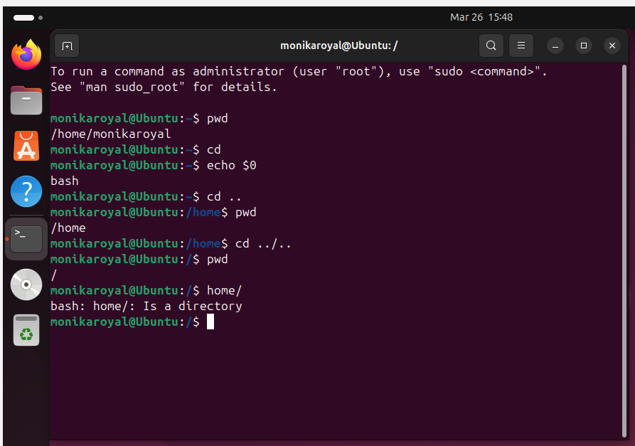

Ls – list of files
Ll- long list

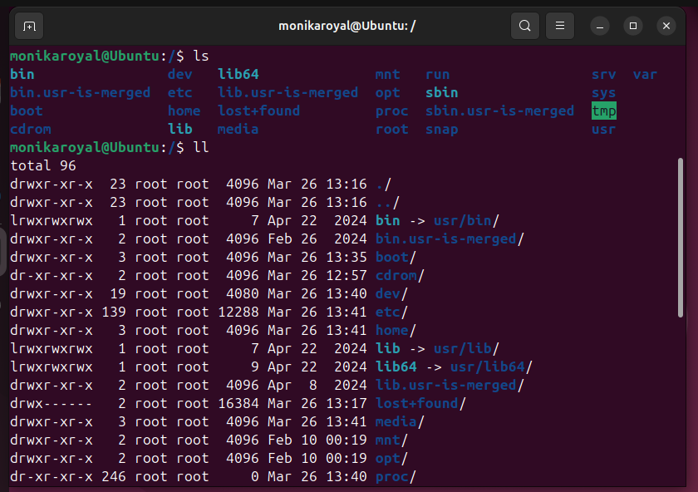

Ltr- list according to time
Ls- a
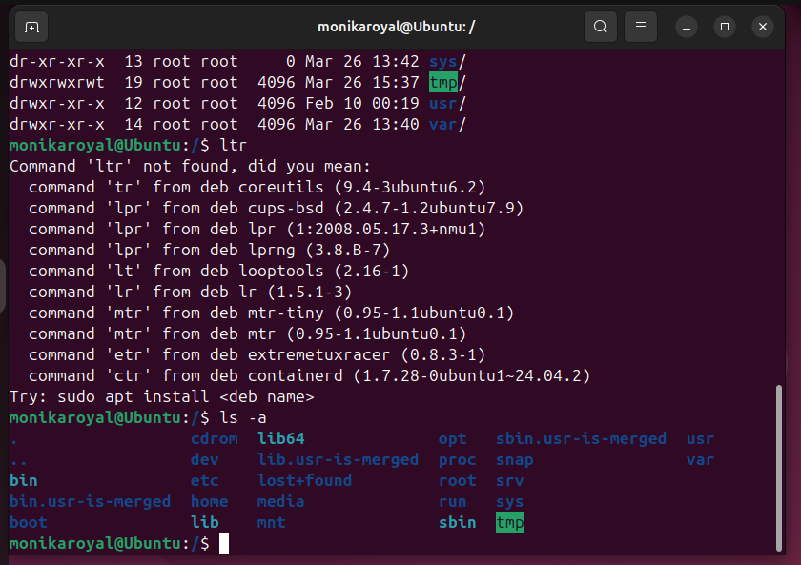

mkdir – To create directory
mv . - To hide the directory
rm -rf – To delete the directory
cp – To copy a directory
touch- to create a file inside a folder

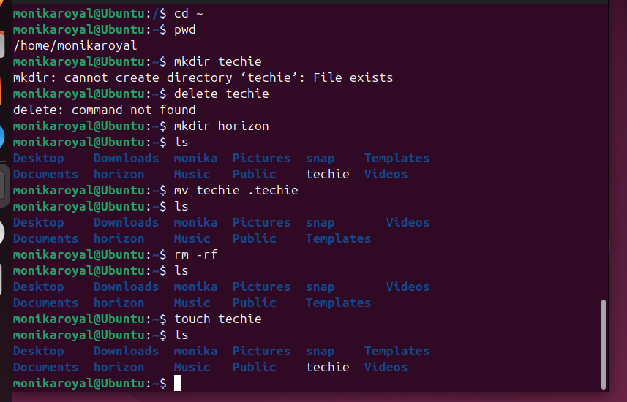

vi – To add text to created file
:wq ! – To save the text
cat – To read the content.
wc- To see the details of directory like how many lines,words etc
date – To see the date
history – To see the history of commands

